Bug Bounty: The Hunter’s Guide
Marcus, N. P
January 16, 2026

Bug Bounty: The Hunter’s Guide
By Marcus, N. P
January 16, 2026

Copyright © 2026 Marcus, N. P.
All rights reserved. No part of this eBook may be reproduced, distributed, or transmitted in any form or by any means, including photocopying, recording, or other electronic or mechanical methods, without the prior written permission of the author, except in the case of brief quotations embodied in critical reviews and certain other noncommercial uses permitted by copyright law.

Preface
The world of cybersecurity is in a state of rapid transformation. As organizations increasingly rely on digital infrastructure, the need for robust, initiative-taking security measures has never been greater. Bug bounty programs—crowdsourced initiatives that reward ethical hackers for naming vulnerabilities—have appeared as a cornerstone of modern security strategies. Bug Bounty: The Hunter’s Guide is an eBook designed to be a thorough resource for new and seasoned bug bounty hunters, as well as organizations wanting to better understand and run successful bug bounty programs.
Drawing on the latest industry data, case studies, and expert insights, this guide covers the full lifecycle of bug bounty hunting: from foundational concepts and legal frameworks to advanced technical methodologies, automation, and reporting. The changing nature of Bug-Hunting.
Whether you are a beginner eager to make your first submission or a seasoned researcher aiming to maximize your impact and rewards, this book provides the knowledge, tools, and ethical grounding necessary to thrive in the bug bounty ecosystem. The digital frontier is vast and ever-changing—let this guide be your trusted companion on the hunt.
Table Contents
1. The Evolution of Bug Bounty Programs
2. Types of Bug Bounty Programs and Scopes
3. Legal and Ethical Considerations for Bug Hunters
4. Virtual Machines and Virtualization for Bug Hunting 5. Common Vulnerability Types and Technical Deep Dives
6. Report Writing: How to Craft High-Quality Bug Reports
8. Testing Web Applications and APIs
9. Mobile and Native Application Bug Hunting
10. Cloud and Infrastructure Security for Bug Bounties
11. Reporting, Triage, and Writing High-Quality Vulnerability Reports
12. Monetization, Career Paths, and Community Building
13. Live Hacking Events, CTFs, and Skill Development
14. Program Design and Metrics for Organizations
15. AI and Machine Learning in Bug Bounty Programs
16. Comparative Analysis of Leading Bug Bounty Programs
17. Ethics, Safety, and Mental Health for Hunters

By the end of this eBook, readers will be able to:
- Understand the history, structure, and current trends of bug bounty programs worldwide.
- Differentiate between types of bug bounty programs, including public, private, and hybrid models, and understand their respective scopes and applications.
- Navigating legal and ethical considerations essential to responsible bug hunting.
- Set up and utilize virtual machines and virtualization platforms for secure, isolated testing environments.
- Identify and exploit common vulnerability types, including XSS, SSRF, RCE, IDOR, and SQLi, with technical depth.
- Employ reconnaissance and information gathering techniques using industry-standard tools and automation.
- Conduct security testing on web applications, APIs, mobile and native applications, and cloud/infrastructure environments.
- Recognize and address supply chain and dependency attacks.
- Write high-quality vulnerability reports and understand the triage process

Chapter 1
The Evolution of Bug Bounty Programs
The concept of rewarding individuals for discovering and reporting software vulnerabilities has roots stretching back to the mid-1990s. Netscape’s pioneering bug bounty program in 1995 set the stage for a new era of collaborative security, offering monetary incentives to external researchers who could identify flaws in its Navigator browser. This model was soon adopted by other technology leaders, including Mozilla, Google, and Facebook, each tailoring their programs to their unique threat landscapes and organizational cultures.
Over the past three decades, bug bounty programs have evolved from experimental initiatives to essential components of cybersecurity strategy. The proliferation of digital assets, the rise of cloud computing, and the increasing sophistication of cyber threats have driven organizations across all sectors to embrace crowdsourced security testing. Today, bug bounty platforms facilitate connections between organizations and a global community of ethical hackers, enabling continuous, scalable, and cost-effective vulnerability discovery.
The industry’s growth is reflected in its financial trajectory. The global bug bounty platforms market reached $1.52 billion in 2024 and is projected to expand to $1.76 billion in 2025, with forecasts estimating a market value of $7.74 billion by 2035. Major technology companies have distributed record-breaking payouts, with Microsoft awarding $17 million in 2025 and Google paying out $12 million in 2024 alone. These figures underscore the maturation of the bug bounty ecosystem and its central role in modern cybersecurity.

Chapter 2
Types of Bug Bounty Programs and Scopes
Bug bounty programs are not monolithic; they vary widely in structure, scope, and participation models. Understanding these distinctions is crucial for both hunters and organizations.
Public vs. Private Programs
Public Programs: Open to all ethical hackers, public programs use the collective expertise of a global community. They offer broad coverage and continuous testing but require robust triage processes to manage high submission volumes.
Private Programs: Invitation-only, private programs restrict participation to a select group of vetted researchers. These programs offer tighter control, lower submission volumes, and are ideal for organizations with sensitive assets or those new to bug bounty initiatives.

Hybrid and Specialized Models
Hybrid programs combine elements of both public and private models, often starting as private and transitioning to public as organizational maturity increases. Specialized programs may focus on technologies (e.g., cloud, mobile, AI) or target specific vulnerability classes.

Scope Definition
Writing and defining the scope is a foundational step in program design. This essential step helps allocate resources efficiently and reduces security risks by outlining precisely which assets and activities are included in the bug bounty program. It will serve as a reference for all involved.
Specific domains, applications, or APIs: For example, a program may include web applications such as the company’s main website, mobile apps for iOS and Android, or payment APIs that process transactions. Clearly listing these assets helps participants focus their efforts on the most critical areas.
Excluded assets: Examples of this may be external platforms such as cloud storage providers, outdated legacy systems that no longer receive regular maintenance, or services operated by outside vendors. Identifying exclusions prevents unintended testing on assets outside the organization’s control.
Permitted testing methods and tools: Examples include penetration testing using automated scanners, manual code review, or fuzzing specific endpoints. By specifying acceptable techniques, organizations can ensure that testing remains safe, legal.
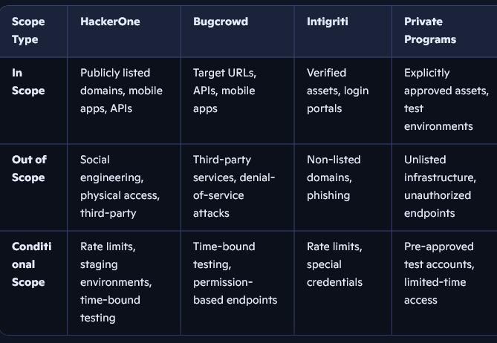

Severity-based reward structures Clear, well-communicated scope boundaries are essential to ensure legal compliance, protect sensitive data, and maximize program effectiveness.

Chapter 3
Legal and Ethical Considerations for Bug Hunters
The line between ethical hacking and illegal activity can be thin, making legal and ethical literacy paramount for bug bounty hunters. Adhering to established frameworks not only protects researchers from legal repercussions but also builds trust and credibility within the community.
Key Legal Frameworks
Computer Fraud and Abuse Act (CFAA): In the U.S., the CFAA criminalizes unauthorized access to computer systems. Testing outside the defined scope of a bug bounty program can result in severe penalties, including fines and imprisonment.
General Data Protection Regulation (GDPR): In the EU, GDPR mandates strict handling of personal data. Exposing or mishandling user data during testing can lead to significant legal consequences.
Safe Harbor Provisions: Many programs include safe harbor clauses, explicitly authorizing certain testing activities and promising not to pursue legal action against researchers who comply with program terms.
clear, concise reports with proof-of-concept (PoC) demonstrations. Maintain confidentiality and professionalism throughout the process.
Navigating Non-Disclosure Agreements (NDAs)
Many programs require researchers to sign NDAs, which can restrict public discussion of findings even after remediation. While these agreements protect organizational interests, overly broad NDAs may hinder transparency and independent verification. Researchers should understand their rights and seek legal counsel when necessary.
Best Practices
- Stick to the Scope: Always operate within the boundaries defined by the program.
- Get Explicit Permission: Only test systems for which you have clear authorization.
- Respect Data Privacy: Avoid accessing or disclosing personal data unnecessarily.
- Report Responsibly: Follow responsible disclosure guidelines, provide detailed, respectful reports and allow organizations time to remediate before public disclosure.
Avoid Exploitation: Never use discovered vulnerabilities for unethical personal gain or to access unauthorized data.

Chapter 4
Bug Bounty Hunting: Tools & Automation
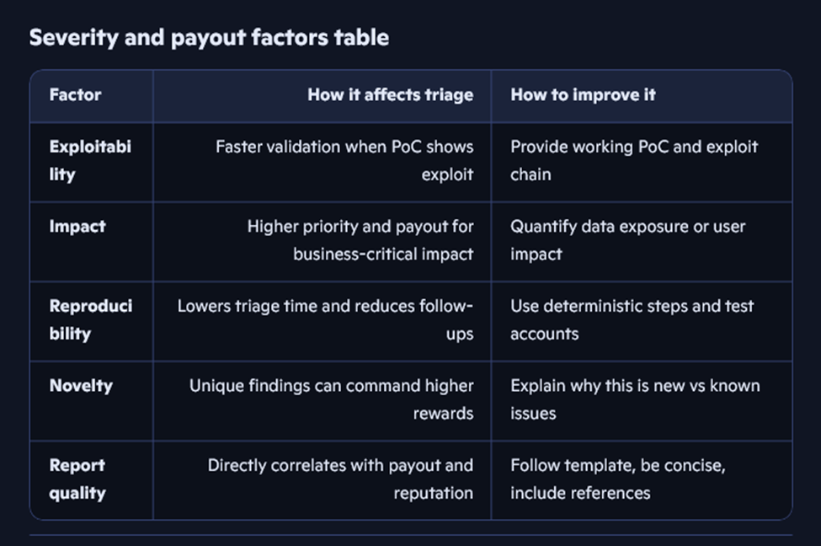A focused toolkit boosts bug hunting efficiency: the following tools are industry standards.
Developing an understanding of essential tools such as Burp Suite, Nmap, Amass, and Sublist3r can significantly enhance your ability to uncover vulnerabilities. Each tool is designed for tasks—scanning, reconnaissance, or exploitation, which makes selecting the right combination crucial.
Each tool has a clear role in the workflow. Automated pipelines increase coverage.
Typically, reconnaissance tools gather subdomains and endpoints, scanners assess vulnerabilities, and exploit frameworks verify findings. Automation bridges gaps between stages, allowing for seamless integration and broader asset monitoring without manual intervention at every step.
Chain tools use scripts for full recon and scanning.
For instance, you might use Bash or Python scripts to run Amass for subdomain discovery, pipe results into Nmap for port scanning, and then trigger vulnerability scanners like Nikto automatically. This chaining streamlines processes and uncovers issues that might be missed if done separately.
Schedule scans to check asset changes.
Scheduling tools such as cron jobs or CI/CD pipelines let you conduct regular scans, ensuring new assets, features, or subdomains are evaluated for potential risks. Continuous monitoring is vital as organizations often update their infrastructure.
Manually verify automated results to minimize false positives.
Automation is powerful but not foolproof. Reviewing scanner output by hand, reproducing findings, and understanding context helps distinguish genuine threats from harmless artifacts. This step supports credibility with clients and improves report quality.
By using these strategies and keeping a balance between automation and manual testing, bug bounty hunters can maximize their effectiveness and adapt to evolving targets and techniques.
Chapter 5
Common Vulnerability Types and Technical Deep Dives
Understanding the technical nuances of common vulnerabilities is critical for effective bug hunting. The following sections provide in-depth analysis of high-value vulnerability classes, supported by real-world case studies and current trends to help connect theory to practice and illustrate the impact of each vulnerability type.
Cross-Site Scripting (XSS)
XSS remains one of the most frequently reported vulnerabilities, accounting for a significant portion of valid bug bounty submissions. Advanced XSS methodologies involve:
- Testing with unique, trackable payloads to identify reflection points.
- Investigating cross-domain implications and propagation of user input.
- Focusing on blind XSS, where payloads are triggered in backend systems or by administrators.
- Bypassing filters and Web Application Firewalls (WAFs) using encoding and obfuscation techniques.
For example, in 2023, a researcher discovered blind XSS vulnerability in a major SaaS platform that was triggered when administrators viewed user-generated content, leading to unauthorized access to internal dashboards. Organizations can defend against XSS by adopting output encoding, implementing Content Security Policy (CSP), and sanitizing user input.
Server-Side Request Forgery (SSRF)
SSRF allows attackers to induce servers to make unauthorized requests, often targeting internal resources or cloud metadata endpoints. Key exploitation techniques include:
- Injecting malicious URLs into parameters processed by the server.
- Bypassing host and protocol restrictions using open redirects, DNS rebinding, or alternative IP encodings. DNS rebinding is a technique that allows attackers to bypass browser security restrictions by manipulating domain name resolution, enabling access to internal network resources.
- Leveraging non-HTTP schemes (e.g., [URL]://) for advanced attacks.
- Chaining SSRF with command injection or privilege escalation for maximum impact.
In a recent bug bounty program, a researcher exploited SSRF by chaining it with open redirect vulnerabilities to access cloud metadata, resulting in the exposure of sensitive API keys. To mitigate SSRF risks, organizations should enforce strict whitelisting of outbound requests, validate user input, and restrict access to internal services from externally facing applications.
Remote Code Execution (RCE)
RCE vulnerabilities enable attackers to execute arbitrary commands on target systems. Exploitation often involves:
- Identifying injection points in file uploads, template engines, or deserialization routines. Template engines are components that render dynamic web pages using user-supplied data, which can be exploited if not properly secured.
- Chaining vulnerabilities (e.g., SSRF to RCE) for deeper system compromise.
- Employing sandbox escape techniques in cloud or containerized environments. Sandbox escape refers to breaking out of restricted environments designed to contain potentially harmful processes.
For instance, in a high-profile case, a bug bounty hunter exploited a deserialization flaw in a popular web application’s template engine, leading to full remote code execution. Defenses against RCE include strict input validation, disabling unsafe deserialization, and applying principle of least privilege to application components.
Insecure Direct Object Reference (IDOR)
IDOR flaws occur when applications expose internal object references without proper access controls. Attackers can manipulate identifiers (e.g., user IDs, document IDs) to access unauthorized resources. Effective hunting strategies include:
- Enumerating predictable identifiers and testing for unauthorized access.
- Combining IDOR with other vulnerabilities (e.g., XSS, CSRF) for greater impact.
In a noted bug bounty case, a researcher accessed confidential reports by incrementing document ID parameters, revealing sensitive information. Organizations can prevent IDOR by enforcing robust authorization checks and using unpredictable identifiers.
SQL Injection (SQLi)
SQLi remains a critical risk, enabling attackers to manipulate database queries and exfiltrate sensitive data. Advanced techniques involve:
- Bypassing input validation and WAFs using encoding and obfuscation.
- Exploiting blind SQLi via time-based or error-based inference. Blind SQLi refers to attacks where error messages are suppressed, so attackers must infer results through timing or logical clues.
- Automating exploitation with tools like SQL Map for efficient testing.
As an example, a researcher in a bug bounty program used time-based blind SQLi to extract user credentials from a financial platform’s database. To mitigate SQLi risks, organizations should implement parameterized queries and rigorous input validation across all database interactions.
Supply Chain and Dependency Attacks
Supply chain vulnerabilities exploit trust relationships in software dependencies. Notable techniques include:
- Dependency confusion: Uploading malicious packages to public repositories with names matching internal dependencies, causing build systems to fetch and execute attacker-controlled code. Dependency confusion is a vulnerability in package management systems where public packages override internal ones due to naming conflicts.
- Monitoring build pipelines and package management configurations for exposure.
For example, in 2021, a bug bounty researcher exploited dependency confusion to execute code within several large enterprises’ CI/CD pipelines. Defenses against supply chain attacks include using private registries, verifying package sources, and monitoring dependency updates for anomalies.
Chapter 6
Report Writing: How to Craft High-Quality Bug Reports
The effectiveness and speed at which bugs are triaged, validated, and resolved is heavily influenced by the quality of your bug report. Detailed and well-written submissions tend to earn higher rewards and enhance the researcher's professional standing.
Essential Elements of a Bug Report
- Title: Should be clear and to the point, identifying both the vulnerability type and the affected system (for example, “Open Redirect in floqast.app/login”).
- Description: Provide a straightforward summary of the vulnerability, including how it was found and relevant context.
- Reproduction Steps: Offer comprehensive instructions for replicating the issue, noting any assumptions made and reasoning behind each step.
- Proof of Concept (PoC): Supply code samples, logs, or images that demonstrate how the flaw can be exploited.
- Impact Assessment: Assess and honestly communicate what could happen if the bug is exploited, especially focusing on serious risks like data exposure or account compromise.
- Remediation Suggestions: Suggest practical fixes for vulnerability and reference reputable resources such as OWASP or CWE.
- References: Include links to documentation, advisories, or related vulnerabilities for additional insight.
Best Practices
- Clarity and Conciseness: Keep language simple and direct; emphasize how the bug can be reproduced and the risks involved.
- Demonstrate Impact: Use concrete evidence, not just explanations, to show how vulnerability can be abused.
- Scope Awareness: Double-check that the issue is within the program’s scope and hasn’t already been submitted.
- Professionalism: Communicate politely and respond quickly to questions from triage teams to help speed up validation and payment processes.
- Continuous Improvement: Take feedback seriously, refine your reporting techniques, and strive to improve greater access to exclusive programs and better compensation.
Key Takeaways
Reconnaissance should be thorough, using both broad and focused approaches with a mix of passive and active methods.

Automation helps boost both efficiency and the likelihood of finding new issues.

Keep your wordlists and reporting templates current to stay ahead of evolving threats.

Chapter 7
Virtual Machines and Virtualization for Bug Hunting
VMs provide safe, isolated environments crucial for bug bounty work, keeping exploits and malware away from host systems and other VMs.
Benefits of Virtualization
- Isolation: Prevents cross-contamination.
- Repeatability: Snapshots allow easy resets for testing.
- Flexibility: Multiple OS setups enable cross-platform tests.
Setting Up a Bug Bounty VM
Use platforms like VirtualBox, VMware, or Qubes-OS. Key elements include:
- Security tools (Burp Suite, Nmap, etc.)
- Automation scripts
- Hardened templates with updated patches
- Network isolation
*Kali Linux Bug Bounty VM Example*
Features may include organized workflows, custom aliases, real-time alert integration, support for CLI/GUI tools, and offline modes.
Mobile Application Testing Labs
Leverage emulators and rooted devices for:
- SSL pinning bypass
- Evasion of root/emulator detection
- Traffic interception
- Dynamic instrumentation

Best Practices
Use snapshots to maintain clean testing environments.
Regularly update VM templates and tools.
Employ network segmentation to control and monitor traffic.
Document configurations for reproducibility and compliance.

Chapter 8
Testing Web Applications and APIs
Web applications and APIs are prime targets for bug bounty hunters due to their complexity and exposure. Effective testing requires a combination of manual and automated techniques.
Web Application Testing
Input Validation: Test all user inputs for injection points (XSS, SQLi, command injection).
Authentication and Authorization: Assess login flows, session management, and access controls.
Business Logic: Identify flaws in application workflows that could lead to privilege escalation or data leakage.
File Uploads: Test for unrestricted file uploads, path traversal, and RCE vectors.
API Security Testing
Endpoint Enumeration: Use tools like Amass and Swaggerhunter to discover undocumented endpoints.
Parameter Fuzzing: Employ Arjun and custom scripts to identify hidden parameters.
Authentication Flaws: Test for broken authentication, token leakage, and improper OAuth implementations.
Rate Limiting and Abuse: Assess for lack of rate limiting, leading to brute-force or denial-of-service attacks.
OAuth and OpenID Connect Vulnerabilities
Improper Redirect URI Validation: Exploit weak validation to steal tokens or perform CSRF attacks.
Scope Manipulation: Attempt to escalate privileges by requesting broader scopes.
Token Leakage: Identify endpoints or flows that expose access to or refresh tokens.
Reporting and Remediation
Document all findings with clear reproduction steps and PoC code.
Suggest practical remediation strategies, such as input sanitization, strict access controls, and secure token handling.

Chapter 9
Mobile and Native Application Bug Hunting
Establishing an effective mobile testing lab is crucial for thorough security assessments. Start by utilizing emulators such as the Android Emulator or Genymotion, which enable rapid testing cycles and provide convenient snapshot management for reverting to previous states. For deeper analysis, incorporate rooted devices using tools like Magisk or Zygisk. These allow for advanced testing techniques, including bypassing SSL pinning and evading root detection mechanism.
Mobile applications are susceptible to a range of vulnerabilities. Test for insecure data storage by checking whether sensitive information is kept in plaintext or stored in locations that lack proper security controls. Assess authentication mechanisms to identify risks such as hardcoded credentials, weak PIN implementations, or potential biometric authentication.
API security is another critical area, requiring analysis of API calls to detect improper authentication, unintended data exposure, and the absence of encryption in data transmissions. Additionally, evaluate SSL pinning and certificate validation to determine whether these protections can be bypassed, allowing for interception and inspection of application traffic.
Several specialized tools can enhance mobile security testing efforts. MobSF provides automated static and dynamic analysis of APK and IPA files, supports API security assessments, and aids in malware detection. Frida enables dynamic instrumentation for real-time analysis and function hooking, making it valuable for runtime investigations. Burp Suite remains a core tool for intercepting and modifying HTTP(S) traffic during manual testing processes.
The OWASP Top 10 is one of OWASP’s most influential projects. It’s essentially a standard awareness document that identifies the 10 most critical security risks for web applications. Organizations worldwide use it as a baseline for securing their applications.
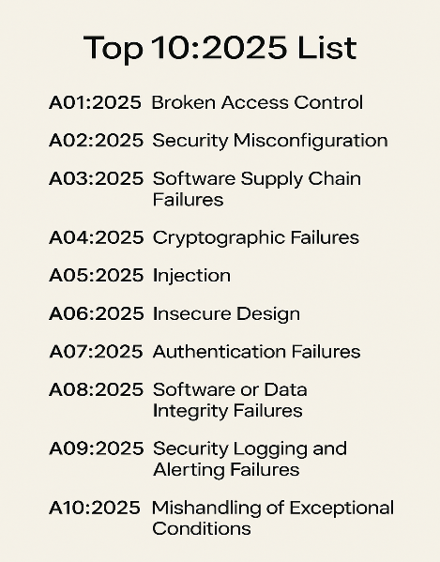
Interception of network traffic is a fundamental aspect of mobile application testing. Configure Burp Suite as a proxy and install custom certificate authorities (CA certificates) on your devices. For dynamic instrumentation and advanced runtime analysis, leverage Frida to hook into application functions and monitor behavior in real time.
For comprehensive test coverage, employ both emulators and real devices. While automation can streamline repetitive tasks, always validate findings manually to ensure accuracy. Stay informed about platform-specific security features and the latest bypass techniques to maintain effective testing strategies in the ever-evolving mobile security landscape.
Best Practices
Use both emulators and real devices for comprehensive coverage.
Employ automation for repetitive tasks but validate findings manually.
Stay updated on platform-specific security features and bypass techniques.

Chapter 10
Cloud and Infrastructure Security for Bug Bounties
Cloud environments introduce new attack surfaces and misconfiguration risks. Bug bounty hunters must adapt their methodologies to address the unique challenges of cloud platforms.
Common Cloud Misconfigurations
Public Storage Buckets: Identify AWS S3, Azure Blob, or GCP Cloud Storage buckets with public read/write access.
Overly Permissive IAM Policies: Detect users or roles with excessive permissions, lack of MFA, or wildcard privileges.
Open Network Access: Scan for open ports, broad security system rules, and exposed management interfaces.
Lack of Logging and Monitoring: Assess for disabled audit logs or insufficient monitoring of critical resources.
Detection and Exploitation
Use cloud-native tools (AWS Config, Azure Policy, GCP Security Command Center) for compliance checks.
Employ open-source tools like Scout Suite, Prowler, and Pacu for multi-cloud security assessments.
Test for privilege escalation, lateral movement, and data exfiltration vectors.
Remediation Strategies
Enforce least privilege in IAM roles and policies.
Enable encryption and logging for all sensitive resources.
Integrate configuration checks into CI/CD pipelines for continuous compliance.
Dependency Confusion: Exploiting package management configurations to inject malicious dependencies into build pipelines, as demonstrated in high-profile attacks against Microsoft, Apple, and others.
Automated Remediation: Organizations like Capital One and Spotify have implemented automated policy enforcement and remediation playbooks to address misconfigurations at scale.

Chapter 11
Reporting, Triage, and Writing High-Quality Vulnerability Reports
Remediation Suggestions
What to include: concrete fixes, code-level hints, and references to standards. Prioritize short-term mitigations and long-term fixes.
Why it matters: actionable guidance shortens remediation cycles.
Example: “Validate against an allowlist of domains; use relative paths only; see OWASP Open Redirect guidance.”
References
What to include: links to OWASP, CWE entries, vendor advisories, or similar CVEs. Why it matters: provides context and authoritative guidance for remediation.
Sample bug report template.
Title
Description
Affected assets.
Impact level
Reproduction Steps (PoC)
Request and response snippets.
Suggested remediation.
References
Attachments (screenshots, logs)

Use this template as a starting point and fill every field. The quality of a vulnerability report directly impacts its acceptance, severity rating, and payout. Clear, actionable reports facilitate efficient triage and remediation. Elements of an Effective Report
Executive Summary: Briefly describe the vulnerability and its impact.
Environment Details: Specify the operating system, application version, and relevant configurations.

Reproduction Steps:
Provide detailed step-by-step instructions to reproduce the issue.
Proof-of-Concept (PoC): Include code, screenshots, or videos demonstrating the exploit.
Impact Assessment: Explain the potential risks, including data exposure, privilege escalation, or monetary loss.
Remediation Recommendations: Suggest practical fixes or mitigations.
Professionalism and Communication
Use clear, concise language accessible to both technical and non-technical readers.
Maintain a respectful and collaborative tone.
Respond promptly to triage questions and requests for clarification.
Maximizing Payouts
Focus on high-impact vulnerabilities and demonstrate real-world risk.
Chain multiple issues for greater severity.
Avoid submitting low-quality or duplicate reports.
Triage Process
Understand that triage teams prioritize critical and well-documented findings.
Be patient and responsive during the validation process.
Learn from feedback to improve future submissions.

Chapter 12
Monetization, Career Paths, and Community Building
Bug bounty hunting offers diverse opportunities for financial reward, professional development, and community engagement.
Monetization Strategies
Tiered Rewards: Most programs offer structured payouts based on severity (Critical, High, Medium, Low).
Quality Multipliers: Exceptional reports may earn bonuses, while poor-quality disclosures may receive reduced payouts.
Specialized Bonuses: Challenge periods, first-time discoveries, and targeted campaigns can increase earnings.
Career Development
Full-Time Hunting:
A minority of elite hunters earn six-figure incomes, often specializing in high-value vulnerabilities.
Part-Time Engagement: Many hunters balance bug bounty work with full-time employment in IT or cybersecurity.
Skill Development: Continuous learning, participation in CTFs, and engagement with the community enhance expertise and reputation.
Community Building
Forums and Discord Servers: Platforms like Hacker One, Bugcrowd, and YesWeHack host active communities for knowledge sharing and collaboration.
Live Hacking Events: In-person and virtual events foster networking, mentorship, and skill development.
Recognition: Hall of Fame listings, swag, and public acknowledgments motivate and reward contributors.
Mental Health and Burnout
Set boundaries and maintain a healthy work-life balance.
Automate repetitive tasks to reduce fatigue.
Engage with the community for support and motivation.
Celebrate small wins and focus on sustainable progress.

Chapter 13
Live Hacking Events, CTFs, and Skill Development
CTFs (Capture the Flag) are competitive cybersecurity games where participants solve hacking challenges to find hidden “flags” (special text strings). They’re used for both fun and education, helping people practice real-world security skills. Live hacking events and Capture the Flag
(CTF) competitions are integral to the bug bounty ecosystem, offering hands-on experience, networking, and recognition.
Live Hacking Events
Some events are Invite-only occurrences, open events usually involve, researchers collaborating and competing to find vulnerabilities in real-time.
Benefits: Direct interaction with program owners, immediate feedback, and substantial rewards. Examples: Microsoft’s Zero Day Quest, YesWeHack’s global events, and Black Hat live hacking villages.
(CTF) Competitions
Gamified challenges simulate real-world vulnerabilities across web, mobile, cloud, and the infrastructure of domains. They aid in skill development for the modern Bug-Hunter: CTFs enhance problem-solving, teamwork, and technical proficiency.
Staying up to date is important:
It is easy to participate in online courses and webinars.
Follow Cybersecurity blogs, podcasts, and newsletters for the latest trends. Try to validate that the sources of your continuous research.
Contribute to open-source projects and write-ups to build reputation and expertise.
TryHackMe, Hack the Box, and PortSwigger Academy for real time practice (These three organizations offer free tier options as of January 2026).

Chapter 14
Program Design and Metrics for Organizations
For organizations, designing an effective bug bounty program requires careful planning, clear objectives, and robust metrics.
Key Design Considerations
Scope Definition: Clearly outline in-scope and out-of-scope assets, testing methods, and reward structures.
Research Engagement: Foster trust and loyalty through transparent communication, prompt triage, and recognition.
Triage and Remediation: Invest in efficient vulnerability validation and remediation workflows.
Metrics for Success: Tracking these metrics enables organizations to assess program health, identify areas for improvement, and demonstrate return on investment.

Chapter 15
AI and Machine Learning in Bug Bounty Programs
Artificial intelligence (AI) and machine learning (ML) are reshaping the bug bounty landscape, enhancing both offensive and defensive capabilities.
The AI-Driven Vulnerability Discovery
Automated Scanning: AI-powered tools can analyze vast codebases and identify patterns indicative of vulnerabilities.
Autonomous Agents: Systems like Google’s Big Sleep and XBOW have demonstrated the ability to discover zero-day vulnerabilities on a scale, sometimes outperforming human researchers. Human-in-the-Loop: Most AI findings are validated by human experts to ensure accuracy and reduce false positives.
Challenges and Limitations
Signal-to-Noise Ratio: AI-generated reports may include hallucinations or low-impact findings, increasing triage workload.
Novelty and Creativity: High-severity, logic-based vulnerabilities remain the domain of skilled human hunters.
Ethical and Economic Implications: The rise of automation may impact entry-level opportunities and necessitate new incentive models.
Future Directions
Augmentation, Not Replacement: The most successful hunters leverage AI to enhance, not replace, their expertise.
Bionic Hacker Model: Teams combining human judgment with machine scale are likely to dominate future leaderboards.
Evolving Reward Structures: New models may reward both discovery and remediation, reflecting the changing dynamics of vulnerability management.

Chapter 16
Comparative Analysis of Leading Bug Bounty Programs
To illustrate the diversity and impact of modern bug bounty programs, we examined four industry leaders: Google VRP, Microsoft Bug Bounty Programs, Meta Bug Bounty Program, and
YesWeHack. The following chart summarizes key statistics and achievements for each program, followed by detailed case studies.
Comparative Chart:
Key Bug Bounty Program Statistics (2024–2025) Google Vulnerability Reward Program (VRP): Case Study
Launched in 2010, Google’s VRP is one of the longest-running and most influential bug bounty programs. It covers a vast array of assets, including Google’s core services, Android, Chrome, Google Cloud, and, more recently, AI products and devices. The program is renowned for its transparency, generous rewards, and continuous evolution to address emerging threats. Best Practices
Clear Scope and Communication: Essential for effective engagement and risk management.
Efficient Triage: Reduces researcher frustration and accelerates remediation. Recognition and Trust: Public acknowledgment, swag, and transparent processes build loyalty and attract top talent.

Chapter 17
Ethics, Safety, and Mental Health for Hunters
Sustaining a long-term, rewarding career in bug bounty hunting requires attention to ethics, safety, and mental well-being.
Ethical Foundations
Always operate within legal and program-defined boundaries. Prioritize responsible disclosure and avoid causing harm. Make sure to engage transparently and respectfully with organizations and peers.
Safety Practices
Use isolated, virtualized environments for all testing.
Maintain detailed documentation of activities for accountability. Documenting every step is of the utmost importance for successful Bug-Hunting and the bounty that follows.
Seek legal counsel when in doubt about program terms or jurisdictional issues.
Mental Health and Burnout Prevention
Make sure to set clear boundaries and keep a balanced schedule. Automate repetitive tasks to conserve energy. Engage with the community for support and motivation. Always celebrate progress and focus on continuous learning. Seek professional help or peer support when experiencing stress or burnout.

Appendix A: Labs and Templates
• Lab Environments: TryHackMe, Hack the Box, PortSwigger Labs, Juice Shop.
• Reporting Templates: Executive summary, environmental details, reproduction steps, PoC, impact assessment, remediation recommendations.
• Figure Placeholders:
• Figure 1: Motivations of Hackers Pie Chart
• Figure 2: Scope Types Diagram
• Figure 3: Bug Bounty vs. Pen Testing vs. VDP Comparison Table
• Figure 4: Bugcrowd Platform Architecture Diagram
• Figure 5: Global Bug Bounty Platforms Revenue Breakdown (2024–2032)
• Figure 6: Top Vulnerability Types Reported (2024–2025)
• Figure 7: AI-Driven Vulnerability Discovery Workflow
• Figure 8: Sample Bug Bounty Report Template

References

To guarantee this eBook's accuracy, relevance, and comprehensive coverage, the following sources were consulted:
• Bug Bounty Program Trends and Highest Rewards in 2025 V-Formation
• Bug Bounty Tips: Strengthening System Security with Virtualization – Bugbounter Blog
• Top Vulnerabilities For Pentest & Bug Bounty in 2025 – NahamSec
• GitHub - Resources for Beginner Bug Bounty Hunters – NahamSec
• Bug Bounty Platforms 2025-2033 Analysis – Data Insights Market
• Bug Bounty Report 2025: Trends and Key Insights – YesWeHack
• Bug Bounty Ethics 101: Legal and Ethical Best Practices – BugBustersUnited
• Successful Bug Bounty Programs in Action – CyberDart
• Top 15 Tools You Must Know for Bug Bounty Hunting – TheHackerStuff
• Public vs Private Bug Bounty Program – CyberDart
• Legal Perspectives on Bug Bounty Programs and Vulnerability Disclosure – SteeleFortress
• Ultimate Guide to Bug Bounty – Bugcrowd
• Bug Bounty Platforms Market Size, Share Industry Forecast, 2035 – Business Research Insights
• SSRF 2025: Techniques and Real-World Examples – SQUID SEC
• How can I automate recon and detect subdomain takeovers using tools like Amass, Subfinder, and Nuclei? – Web Asha Technologies
• OAuth 2.0 Authentication Vulnerabilities – PortSwigger
• Awesome-Bugbounty-Writeups – GitHub
• 10 Best Reconnaissance Tools for Bug Bounty Hunters – Senselearner
• GitHub - Bugbounty-VM – 0x0806
• Leveraging OAuth Misconfiguration: A Practical Bug Bounty Exploitation – RMSec
• How to Become a Bug Bounty Hunter in 2025? – Geekflare
• Dependency Confusion Supply-Chain Attack Hit Over 35 High-Profile Companies – The Hacker News
• A Step-by-Step Guide for Security Researchers to Maximize Payouts – Inspectiv
• GitHub - Cloud-Misconfig-Exploit-Guide – nukIeer
• 5 Stages of Becoming a Bug Bounty Hunter in 2025 – AppinIndore
• Bug Bounty Reports: A Detailed Guide (Examples & Templates) – GoGetSecure
• Upcoming Events Meet YesWeHack Team Worldwide
• How to get better results from bug bounty programs without wasting money – Help Net Security (“How to get better results from bug bounty programs without wasting ...”) (“How to get better results from bug bounty programs without wasting ...”)
• Zero Day Quest Live Hacking Event 2025 – Microsoft
• Was 2025 the year AI broke the bug bounty model? – Cybernews
• Metrics that Matter: Your Guide to Defining Bug Bounty Program Goals – Bugcrowd (“Metrics that Matter: Your Guide to Defining Bug Bounty ... - LinkedIn”)
• Bug Bounty Burnout: Stay Motivated and Mentally Strong – LinkedIn
• Meta Paid Out $4 Million via Bug Bounty Program in 2025 – SecurityWeek
• Google says its AI-based bug hunter found 20 security vulnerabilities – TechCrunch (“Google Says Its AI-Based Bug Hunter Found 20 Security Vulnerabilities”)
• Creating a Kali Linux TemplateVM – Qubes OS Forum
• GitHub - samirettali/kali: Kali Linux containers for bug bounty and CTFs

